Bridget Brinkman

Professor Flynn

ENGCMP 0610

22 May 2024

Creator Statement and Project Reflection

In my project, I narrate a story from my childhood golf summer camp tournament over the sounds of me practicing at my local driving range. I used a Zoom H5 Handy Recorder from the Hillman Library to capture my audio clips and a Logitech Blue Yeti USB microphone to record my narration. I layered appropriate sounds over different parts of the story, including practice swings, drives, and putts. My audio includes birds chirping, muffled music, and other people conversing at the range. The background noise creates a fast-paced, succinct tone that merges well with the pace of my narration.

My initial concept was to record a day golfing with friends. The first challenge I faced was having my tee time canceled, which meant I could not record sounds from the golf course at all. Due to the time constraints of the library and the accelerated summer course, I had to think on the fly and come up with another plan. I decided to record at the driving range. Something positive I realized was the variety of audio involved in even the most mundane aspects of everyday life. After moving my project to the driving range, I was hopeful that I could capture a similar yet different story with equal sound variety and depth. Many ideas came to mind, such as the sounds created by the ball dispensing machine and pouring balls into my tray.

When I got home and reviewed my clips, it occurred to me that my brain filters out a lot of everyday background noise. I knew my job editing would be easier if I could capture audio with minimal background noise. I ended up liking the way my narration sounded including the background noises at the range.

My next task was to combine my clips to tell a story. At this point, I only had sounds of me driving. I knew I would need more, maybe I could organize my clips in descending order, from driving, to chipping, to putting. This would wind the audience down from the loudest sounds of golf to the more soothing ones, giving them a sense that the story would conclude with putting.

I decided to experiment with recording other sounds, such as making coffee and brushing my teeth, to give the audience more of a sense of daily routine. These clips were difficult to record and made my project more confusing, so I scrapped them. I found that editing my project down to the essence of golf painted a clearer picture of time, place, and setting. I have learned making errors is very important to learn how to make successes. I embraced some of the errors that occurred over the week, and some were flat out annoying and frustrating.

I was still hesitant about my golf vision, so I went on a hike and recorded more sounds. Most of the clips were unusable. There were a lot of unwanted sounds, such as accidentally rubbing the microphone and wind. If I attempted to record a hike again, I would bring a set of headphones to listen to make sure I was capturing what I intended.

As the deadline neared, I sat with a 1:30 “story” of pure golf sounds at the driving range. I felt it did tell a story in a way, but I felt that it was not enough. To add a human element, I decided to narrate a story from my childhood, which required rearranging clips and adjusting volumes. This narration added depth and sentimentality to my soundscape, making it more engaging and personal. I recorded two takes, and the first sounded the best. I took one sentence from the first take and replaced it with the same sentence from the second take.

The project taught me about the complexities of creating good audio and storytelling. I realized real-life sounds often differ greatly from sounds we hear on television, the internet, and in cinema. I realized audio composition and engineering is a profession because this is a difficult process! This project was fun and I enjoyed the process. 😊

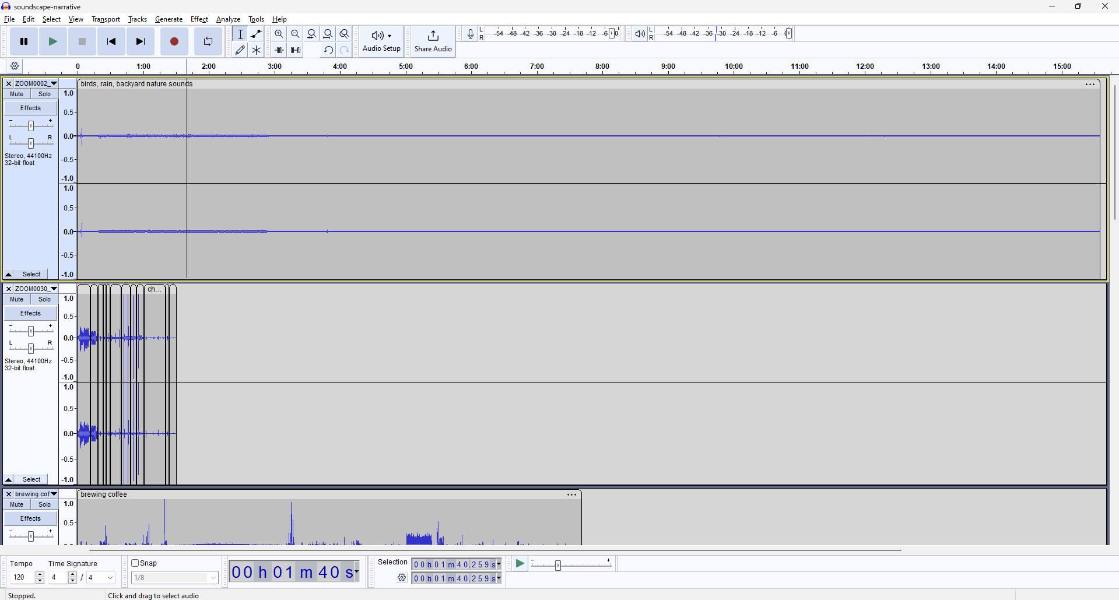

Project start:

The Hillman microphone is amazing!

I recorded 15 minutes of rain and birds in my backyard

Good potential background audio (ended up being unused)

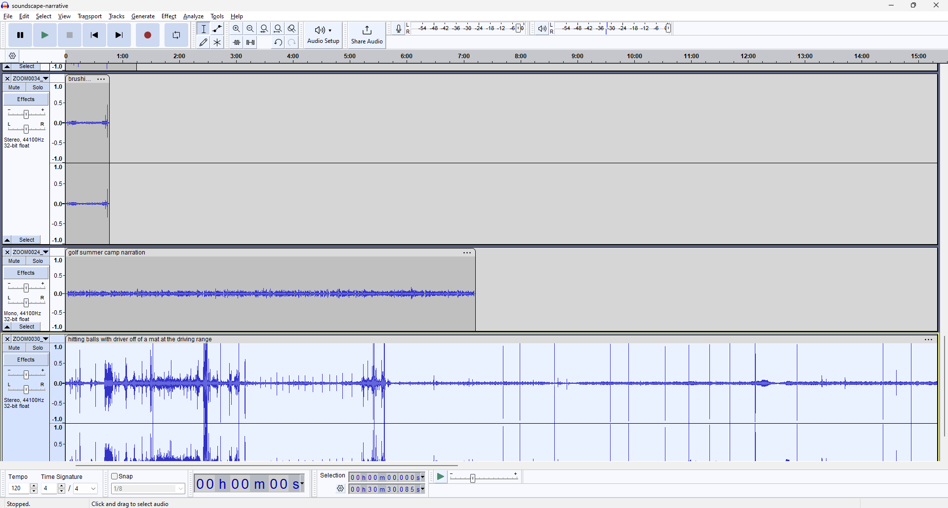

Over the week I recorded 58 separate audio recordings

Very cool wave forms produced by driving balls at the range

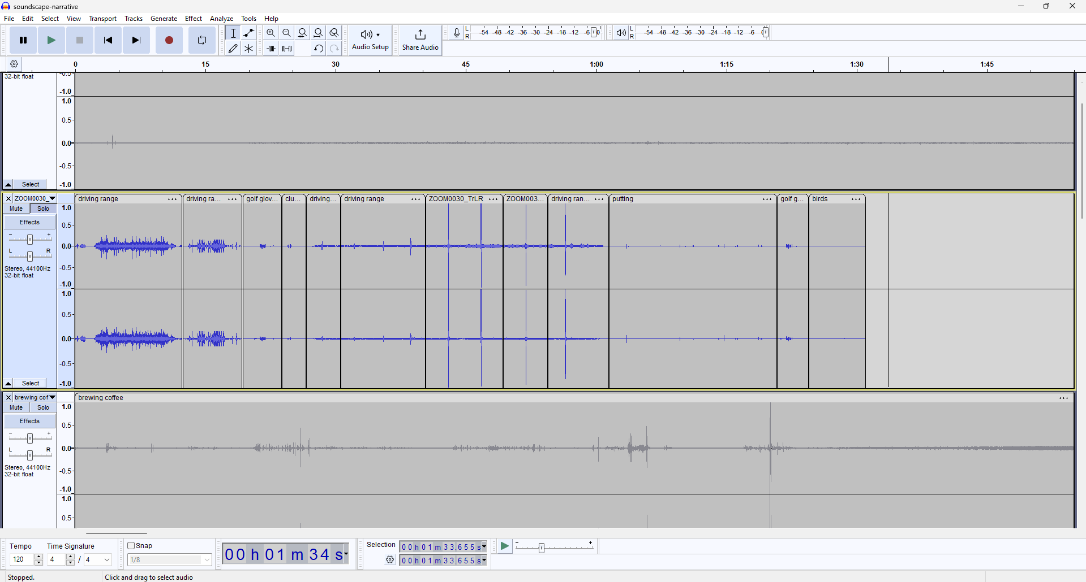

My first draft

“Golf story” told solely through golf sounds (no narration)

Story begins with ball dispensing machine, followed by drives, putts, and ends with me un-velcroing my glove

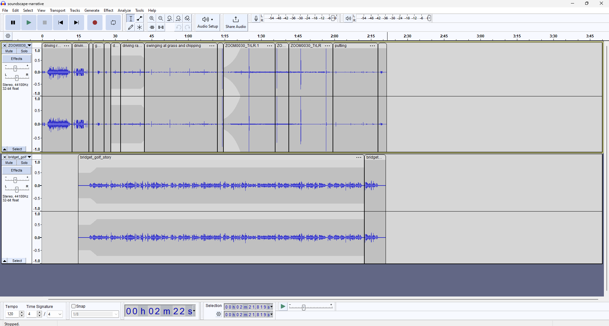

A new idea, narration!

The final product!

Added narration and moved around distinct sounds to fit the narration better